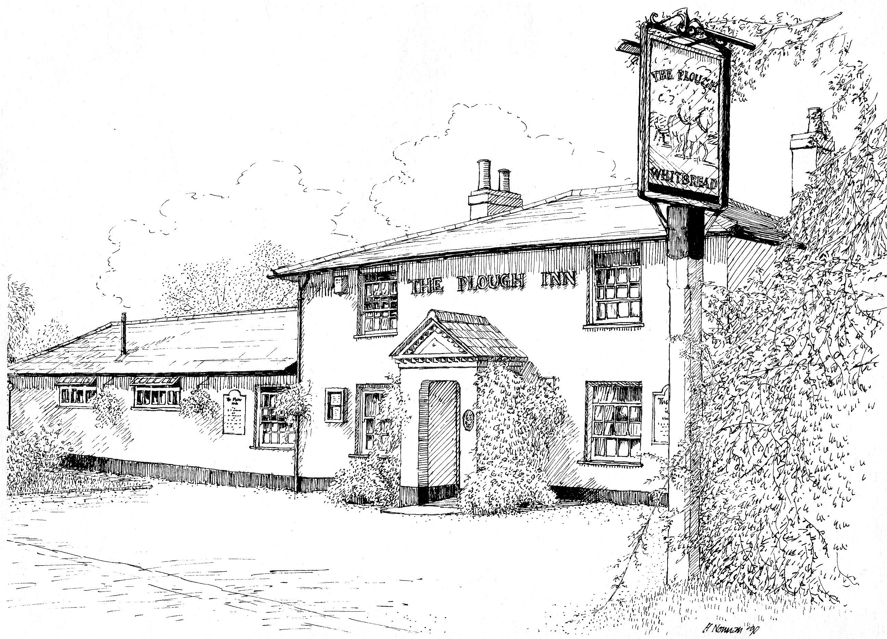
The Plough Inn
Tiptoe Sway Road Lymington SO41 6FQ
01425 610185 www.ploughinnnewforest.co.uk

Small Appetite Menu ♦ £7.95

Spaghetti Bolognaise
Served with garlic ciabatta bread

♦♦♦

Cider Braised Pork Belly
Served with sauté potatoes, a homemade cider sauce
and fresh vegetables

♦♦♦

Scampi & Chips
Served with peas and tartar sauce

♦♦♦

Lager & Lime Beer Battered Fish
Served with chips, peas and tartar sauce

♦♦♦

Three-Bean Chilli (V)
Served with rice, sour cream and tortilla chips

The Plough Inn
Tiptoe Sway Road Lymington SO41 6FQ
01425 610185 www.ploughinnnewforest.co.uk

Small Appetite Menu ♦ £7.95

Spaghetti Bolognaise
Served with garlic ciabatta bread

♦♦♦

Cider Braised Pork Belly
Served with sauté potatoes, a homemade cider sauce
and fresh vegetables

♦♦♦

Scampi & Chips
Served with peas and tartar sauce

♦♦♦

Lager & Lime Beer Battered Fish
Served with chips, peas and tartar sauce

♦♦♦

Three-Bean Chilli (V)
Served with rice, sour cream and tortilla chips

The Plough Inn
Tiptoe Sway Road Lymington SO41 6FQ
01425 610185 www.ploughinnnewforest.co.uk

** Stonebaked Pizzas **

Our pizzas are made with a 12” thin crust base topped

with a tomato sauce and mozzarella

Margherita £11.50

♦♦♦

Pepperoni £12.00
Topped with sliced pepperoni

♦♦♦

The Farmhouse £12.25
Topped with diced ham, sliced mushroom,
red onion and diced chicken

♦♦♦

The Hot and Spicy £12.25
Topped with diced Cajun chicken, sliced pepperoni,
jalapenos and red onion

♦♦♦

The Mighty Veggie £11.75 (V)
Topped with oven baked mediterranean vegetables

♦♦♦

The Meat Feast £12.50
Topped with diced ham, chicken, bacon and pepperoni & spicy beef

♦♦♦

The Hawaiian £12.00
Topped with diced ham and diced pineapple

♦♦♦

The Texan £12.25
Topped with diced chicken, spicy beef, red onion and BBQ sauce

The Plough Inn
Tiptoe Sway Road Lymington SO41 6FQ
01425 610185 www.ploughinnnewforest.co.uk

** Stonebaked Pizzas **

Our pizzas are made with a 12” thin crust base topped

with a tomato sauce and mozzarella

Margherita £11.50

♦♦♦

Pepperoni £12.00
Topped with sliced pepperoni

♦♦♦

The Farmhouse £12.25
Topped with diced ham, sliced mushroom,
red onion and diced chicken

♦♦♦

The Hot and Spicy £12.25
Topped with diced Cajun chicken, sliced pepperoni,
jalapenos and red onion

♦♦♦

The Mighty Veggie £11.75 (V)
Topped with oven baked mediterranean vegetables

♦♦♦

The Meat Feast £12.50
Topped with diced ham, chicken, bacon and pepperoni & spicy beef

♦♦♦

The Hawaiian £12.00
Topped with diced ham and diced pineapple

♦♦♦

The Texan £12.25
Topped with diced chicken, spicy beef, red onion and BBQ sauce

